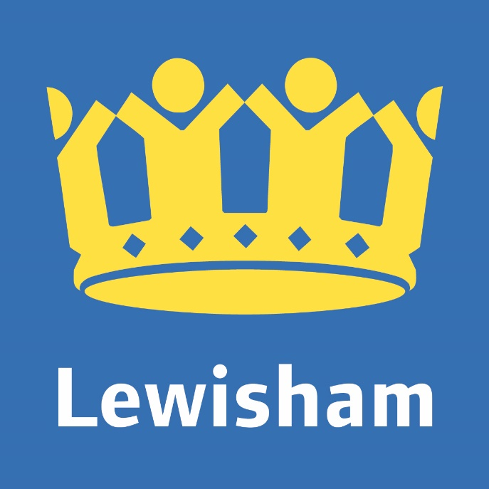

London Borough of Culture 2022

**Lewisham 2022 - Artists of Change Call Out**

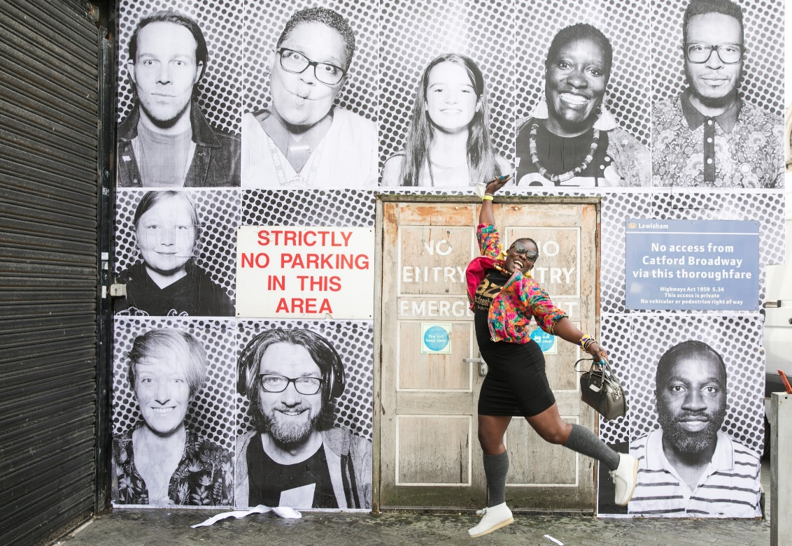

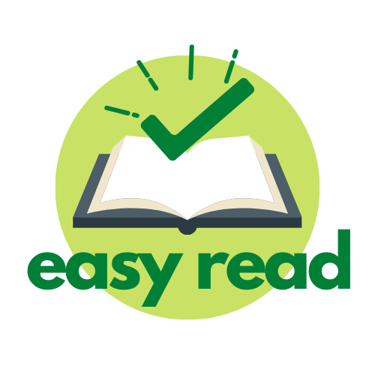

**The Mayor of London’s Borough of Culture**

Lewisham is an area of London, full of lots of different people and places.

Borough of Culture is a year of events that the Mayor of London awards to a different borough each year.

Lewisham is going to be Borough of Culture in the year 2022. This means that there will be lots of events, activities and art in Lewisham in 2022.

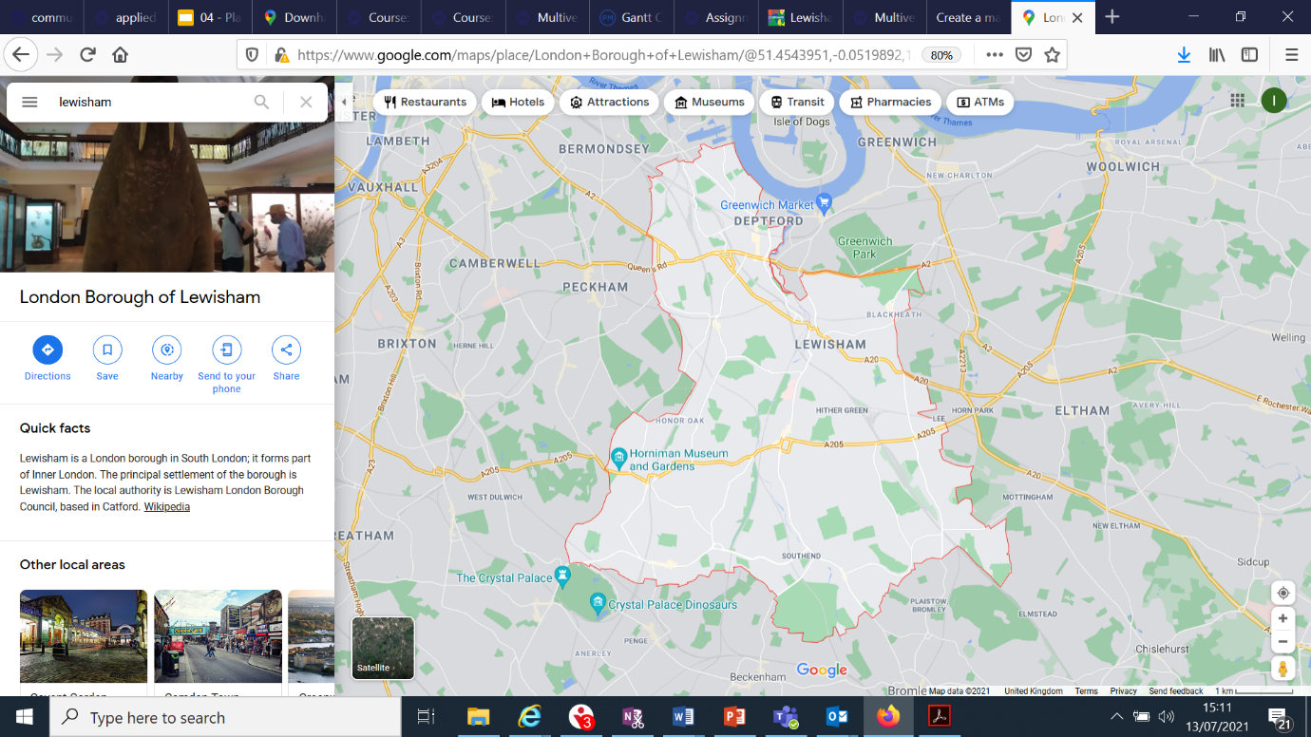

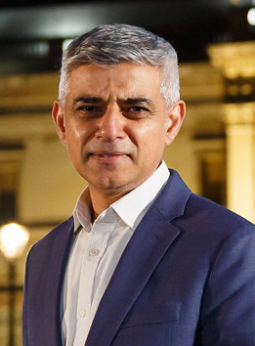

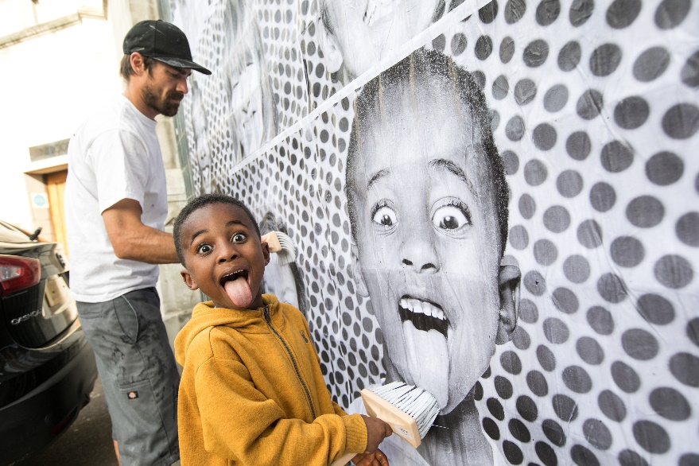

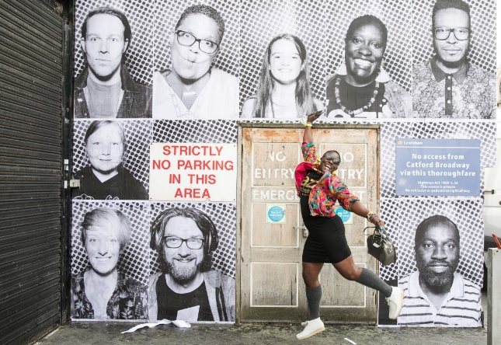**Lewisham 2022 Artists of Change Residency**

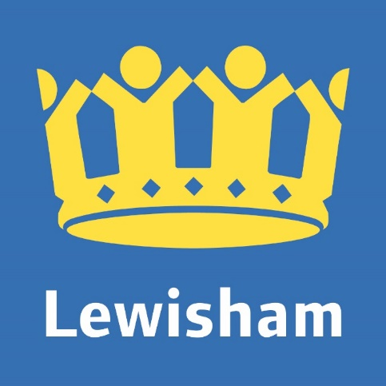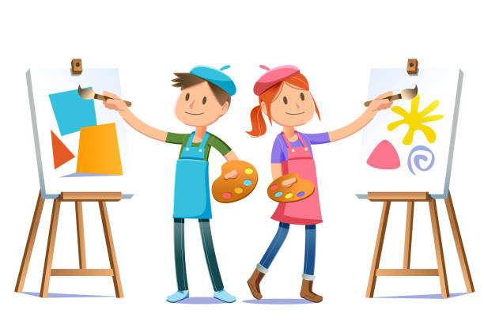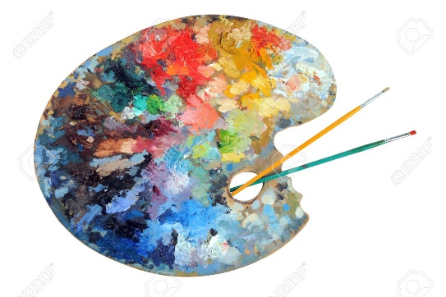

Lewisham Council is inviting two artists, artist collectives or companies to join the Council for a 6 month artist residency, with Counterpoints Arts.

An artist residency is time that an artist spends within an organisation. The *Artists of Change* residency will mean the artists will create artwork to help inform decisions, raise issues and connect people across Lewisham and the Council.

To become one of the *Artists of Change,* you have to meet some requirements and tell us what you will plan to do.

There are two residencies available within the Council: the Borough of Sanctuary residency, and the Climate Emergency Residency.

**The Project Vision**

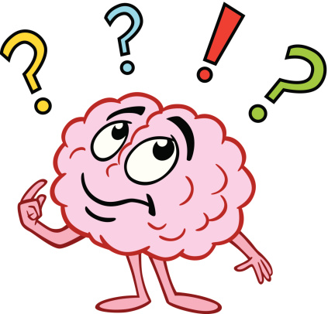

The aim of the residencies is to think about key issues and challenges from new perspectives.

The Borough of Sanctuary Team maintains Lewisham’s approach to resettlement in the borough. It ensures that Lewisham is a welcoming home to refugees. Artists applying for the residency in this team will need lived experience of migration or displacement.

The Climate Emergency Team acts in response to issues around climate. They are working to make Lewisham as climate friendly as possible.

Projects can be any kind of creative activity, like dance, painting or theatre. But we are really interested in interactive work that involves the community.

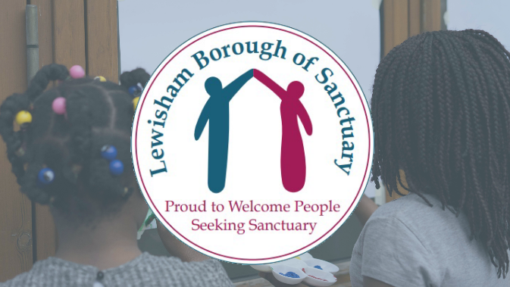

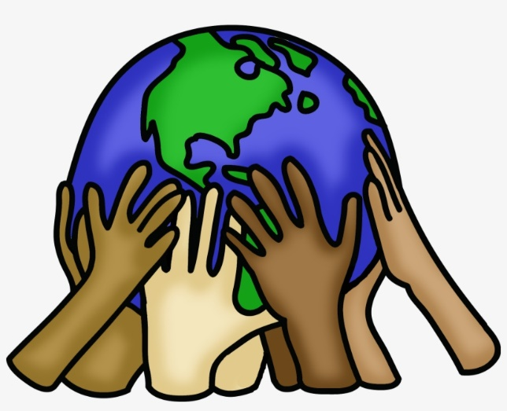

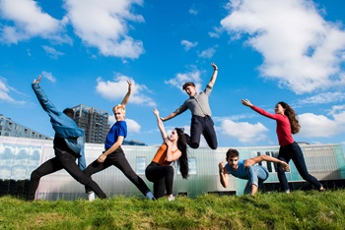

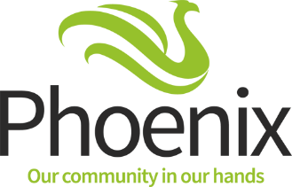

**What We Are Looking For**

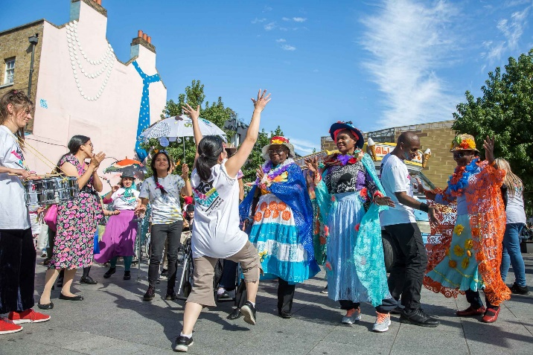

Applications must have a strong connection to Borough of Sanctuary, or Climate Emergency, & show you are interested in:

* Inspiring change within society
* Engaging the community in thought-provoking, accessible artwork
* Tackling social issues
* New ways of working in response to the residency
* Bringing Lewisham closer together
* Using public space to make sure everyone is able to see the work
* One, or more, of the following: politics, climate emergency, identity and issues affecting people.

You should be UK-based and able to show a connection to the Borough of Lewisham.

You can make work of any kind, such as; music, dance, poetry, performance, sculpture, cabaret or comedy. We are interested in how your project can inspire change.

The new work that comes from the residency will be presented as part of Refugee Week in 2022.

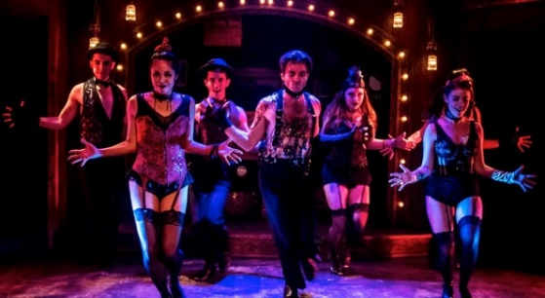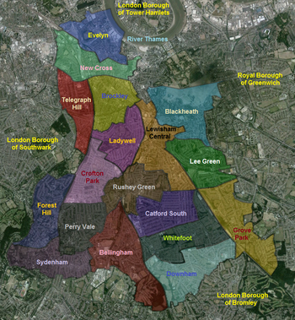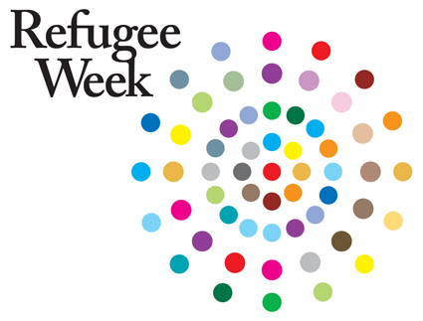

**What To Include In Your Application**

There are some things we want to know about you and your ideas:

* Your full name and contact details (email address or phone number).
* Which residency you are applying for (Borough of Sanctuary or Climate Emergency).
* The Borough of Sanctuary residency will be given to an artist who has experience of migration and being displaced. If you are applying to this one, do you meet this criteria?
* Some background information on your art practice.
* Why you are interested in being an Artist of Change.
* What kind of thing you would plan to do as an Artist of Change.
* Tell us about any additional experience you have that you think is relevant



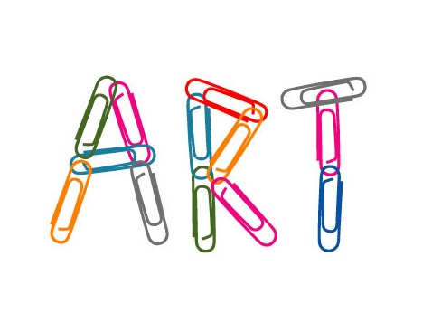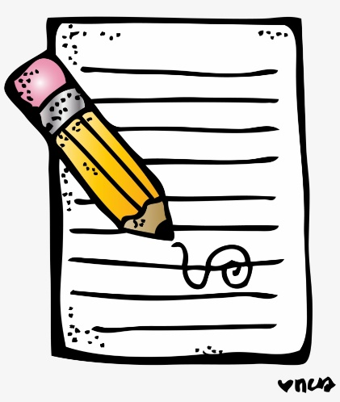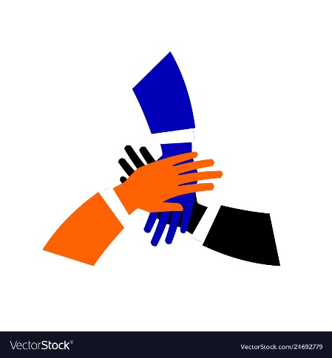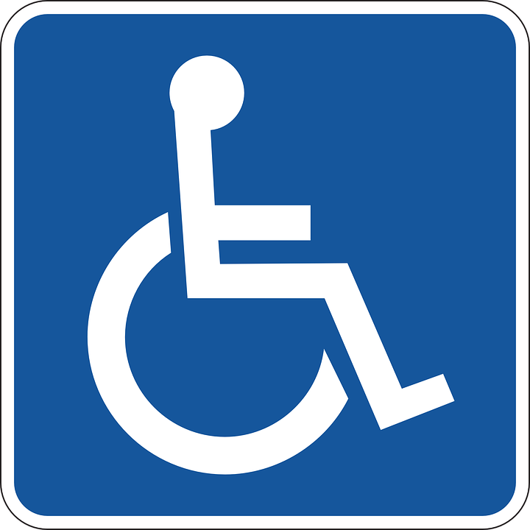

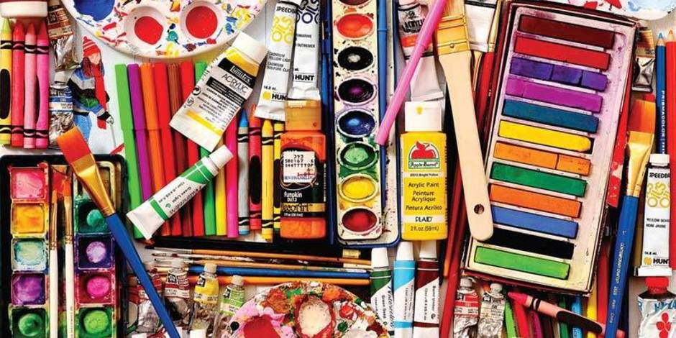**Artist Fees**

This is a paid opportunity.

Each Artist of Change will be in residency for 2 days per week. Each residency will be 6 months long. You will be paid £12,000 for this period.

Whilst you are an Artist of Change, you will have artwork commissioned. This means people will ask you to make art specifically for things. For each commission, the Artist of Change will receive a payment of £1,500.

When you are making work, you will have to buy things like materials, or pay for running costs of machines and tools or suppliers. To help you cover these costs, we will offer you up to £10,000 per residency.

**How to apply**



Follow the link below to fill out an application form. <https://forms.gle/kKkYQZtdTPARsTiq7>

We are also accepting applications via audio/video recording. These can be a maximum of 5 minutes long and need to answer the questions above. Please email these to

[cultural.development@lewisham.gov.uk](mailto:cultural.development@lewisham.gov.uk) with the subject ‘Artist of Change Application’.

Please do not submit an audio/visual recording, and an online form. We only need one application per artist/collective. If you have any questions about the brief, please email [cultural.development@lewisham.gov.uk](mailto:cultural.development@lewisham.gov.uk)

The deadline for applications is 1st October 2021.

Following this deadline, applications will be reviewed. Those that are shortlisted will be asked to submit a full application. £250 will be offered to cover the time spent on this application.

We will get back to you by 19th September 2021.



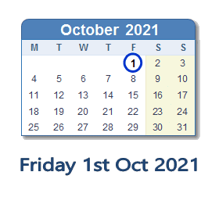



**Timescale, Application Process & Support**

|  |  |
| --- | --- |
| **1st October** | * Deadline for 1st round of applications   If your application is successful we can contribute towards access support costs for you or your creative partners, in addition to the artist fee.  We expect a lot of applications so we may not be able to respond to every applicant with individual feedback. Once we have chosen the applicants for the next stage, we’ll publish how we made our decision. |
| **Mid-October** | * Artists informed of outcome * Shortlisted artists invited to submit a full application |
| **December** | * Chosen artists introduced |
| **January** | * Detailed plans for residency are put together |
| **February** | * Artists start working with communities |
| **May** | * Rehearsals begin |
| **June** | * Public outcomes as part of refugee week |
| **July** | * Evaluation of the residency |